Detailed Design
- Introduction
Purpose: The purpose of our system "WePool" is to offer shared rides to workers within the same organization. This way , workers can consolidate existing friendships and create new ones , discuss matters that relate to work or common interests and above all cut significantly the money spent on commuting.
System overview: "WePool" strives to function as a comprehensive intra – organizational platform to connect commuting workers. The system integrates an effective and reliable routing algorithm by Waze and a self – made matching algorithm to connect drivers and passengers based on constraints applied beforehand. Our system aims to be an user friendly mobile Android app which features 3 main user types (Admin, HR manager and worker) with varying degrees of authorization.

- Key Components
- Mobile App: The app serves as the primary interface for the users (passengers, drivers, HR managers, and admins).
- Server-Side Backend: The backend processes all requests, manages role-based access, interfaces with the Waze/Google Maps API for route optimization, retrieves and updates data from the database, and handles notifications. The notification system within the backend triggers alerts to users based on events such as ride updates, schedule changes, or requests.
- Ride Matching Service: This service, powered by the Waze/Google Maps API, evaluates and optimizes driver routes. It calculates deviations caused by adding passengers and ensures the updated route adheres to predefined thresholds by the driver (e.g., a 10-minute maximum detour).
- Database: The database stores all user accounts, ride details, company settings, and usage statistics. It ensures data persistence and supports analytics for admins and HR managers.
- Admin Panel: Provides admins with tools to configure global settings, manage companies, and oversee system-wide analytics.
- HR Manager Dashboard: Enables HR managers to manage workers, monitor ride statistics, and enforce company-specific policies
- Driver Features: Drivers can create and manage ride offers, accept passenger requests. Routes are optimized using Waze/Google Maps for efficiency.
- Passenger Features: Passengers can search for and book rides, manage their ride history, and receive real-time updates.
How They Interact
- Mobile App ↔ Backend: The mobile app sends user requests to the backend, which processes the logic and returns results.
- Backend ↔ Waze API: The backend integrates with Waze/Google Maps to fetch route data and evaluate deviations for ride matching.
- Backend ↔ Database: All user, ride, and system data are stored and retrieved from the database.
- Admin Panel & HR Manager Dashboard ↔ Backend: These interfaces allow admins and HR managers to configure settings and retrieve analytics via backend interactions.
- Passenger ↔ Backend: Passengers interact with the backend to search for available rides, book rides and receive notifications about ride updates or changes. The backend processes these requests, retrieves relevant ride details from the database, and provides real-time updates.
- Driver ↔ Backend: Drivers communicate with the backend to create and manage ride offers, accept or reject passenger requests, and optimize routes through the Waze/Google Maps API. The backend ensures all ride-related data is updated in the database and notifies drivers of new requests or changes.

- Design Considerations
Assumptions:
- Users have stable internet access.
- Users will access the app via Android devices running version 8.0 or higher.
- Users will turn on the location service before opening the app.
Constraints:
- Initial scalability is limited to 100 users per company.
- The backend can handle up to 100 concurrent requests in the initial phase.
- Daily API requests to Waze are limited (e.g., 1,000 calls/day during initial deployment).
- The database can initially store up to 100 GB of data, including user accounts, ride history, and analytics.


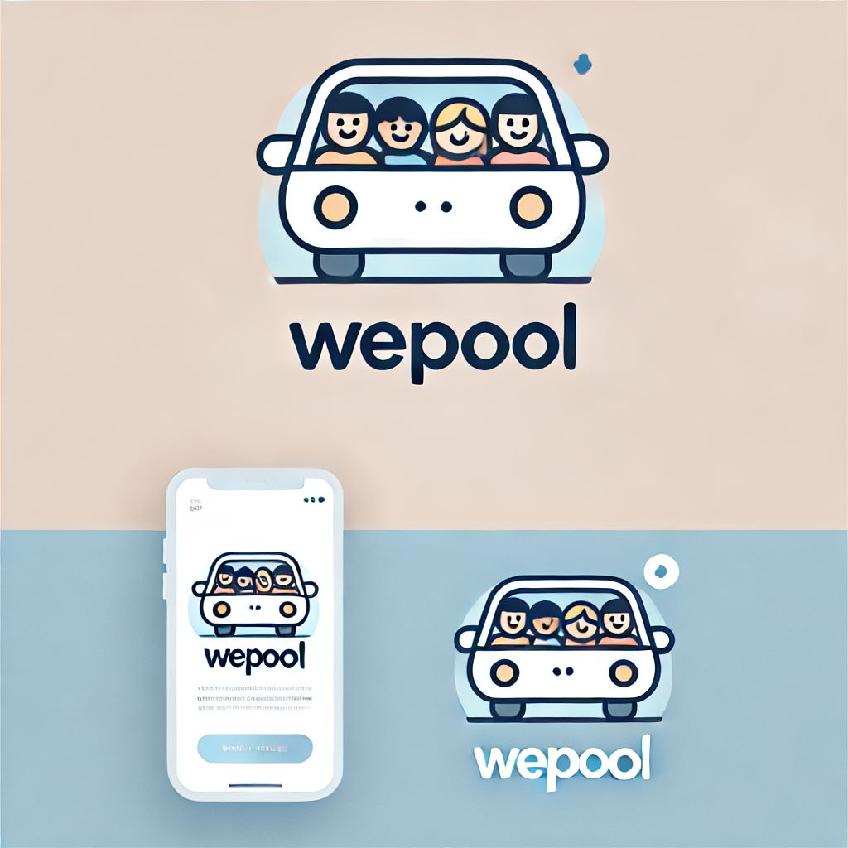
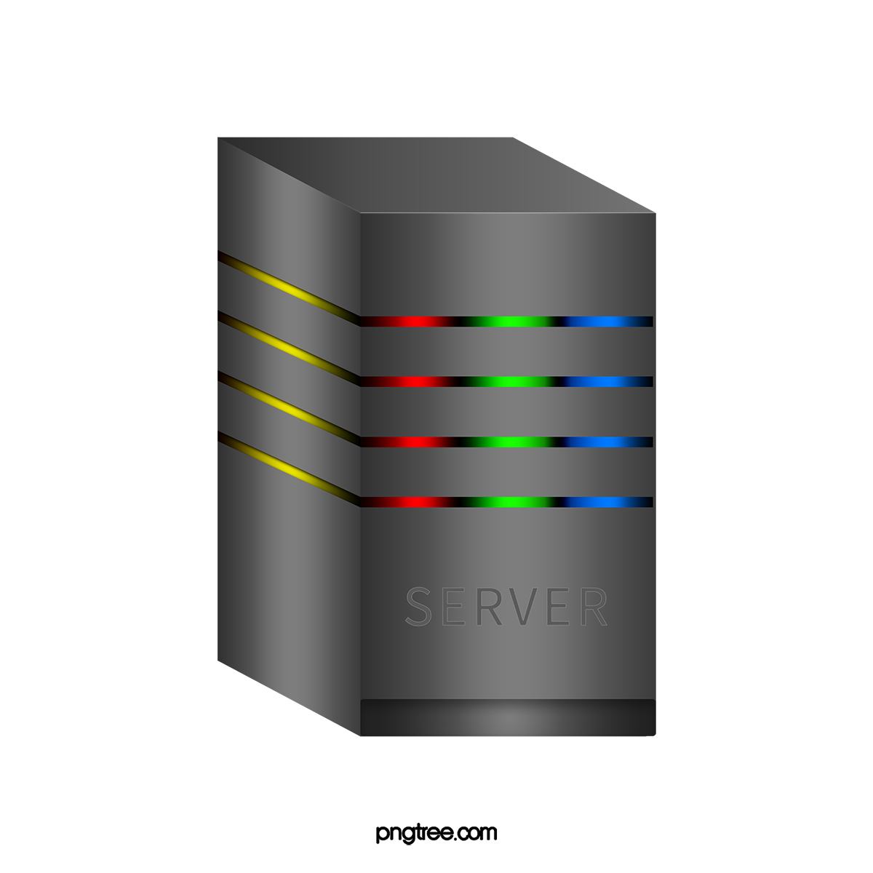
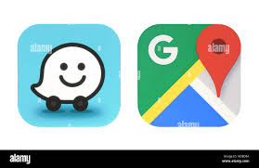
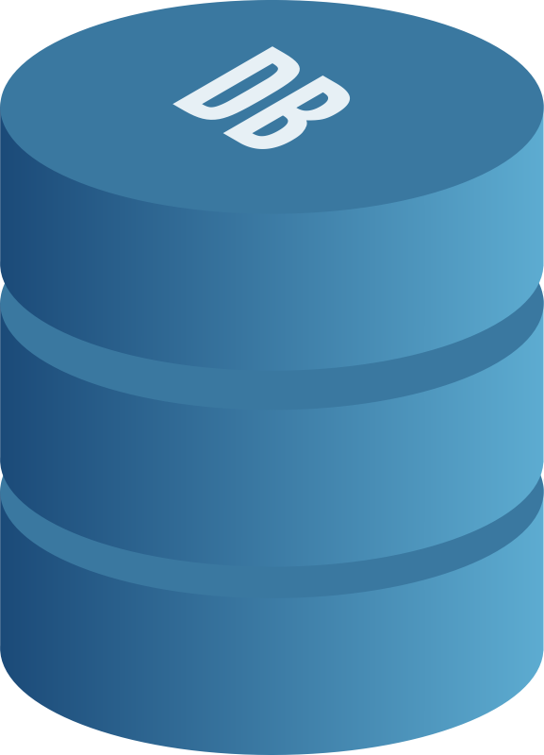
- System Architecture
user
Mobile app
Server-Side Backend
Waze/Google Maps API
Data Base

- Users:
  - Includes all roles: passengers, drivers, HR managers, and admins.
  - Initiates interactions with the system via the mobile app.
- Mobile App:
  - Acts as the client-side interface for all users (passengers, drivers, HR managers, and admins).
  - Sends user requests (e.g., ride searches, ride creation, or settings updates) to the backend.
  - Receives responses from the backend, such as ride-matching results, notifications, and updated data.
- Server-Side Backend:
  - Core Logic: Processes all user requests from the mobile app, manages role-based access, and enforces permissions.
  - Ride Matching Service: It integrates with the Waze/Google Maps API to calculate optimized routes, evaluate deviations, and match passengers with drivers while adhering to driver-defined thresholds (e.g., a 10-minute maximum detour).
  - Notification System: It triggers alerts and updates for users based on events like ride confirmations, cancellations, or schedule changes.
  - Database Operations: The backend retrieves and updates data from the database to ensure consistent user, ride, and system data management.
- Waze/Google Maps API:
  - Provides real-time traffic and route optimization data.
  - The backend queries Waze/Google Maps through the Ride Matching Service to fetch updated route calculations for drivers and ensure optimized ride assignments.
- Database:
  - Stores all system data, including user accounts, ride details, company-specific settings, and logs for analytics.
  - Supports persistent data storage for backend operations and ensures seamless access for admins, HR managers, and regular users.

Technological Requirements:
- Development Environment: Android Studio.
- Programming Languages: java for app development and backend algorithms.
- Database Technology: PostgreSQL.

- Data Design
Key entities include user, passenger, driver, ride, HR manager, admin, company, admin – company relationship, HR manager – company relationship.
The database schema:
- User table:
- user_id INT PRIMARY KEY AUTO_INCREMENT
- name VARCHAR(100) NOT NULL
- email VARCHAR(150) UNIQUE NOT NULL
- password VARCHAR(255) NOT NULL
- role ENUM('Admin', 'HR Manager', 'Driver', 'Passenger') NOT NULL
- company_id INT
- is_banned BOOLEAN DEFAULT FALSE
- created_at TIMESTAMP DEFAULT CURRENT_TIMESTAMP
- FOREIGN KEY (company_id) REFERENCES Company(company_id)
- Passenger table:
- passenger_id INT PRIMARY KEY
- preferred_pickup_location VARCHAR(255)
- ride_preferences VARCHAR(255)
- FOREIGN KEY (passenger_id) REFERENCES User(user_id)
- Driver table:
- driver_id INT PRIMARY KEY
- vehicle_details VARCHAR(255)
- available_seats INT
- FOREIGN KEY (driver_id) REFERENCES User(user_id)
- Ride table:
- ride_id INT PRIMARY KEY AUTO_INCREMENT
- driver_id INT NOT NULL
- start_location VARCHAR(255) NOT NULL
- end_location VARCHAR(255) NOT NULL
- start_time DATETIME NOT NULL
- available_seats INT NOT NULL
- company_id INT
- created_at TIMESTAMP DEFAULT CURRENT_TIMESTAMP
- FOREIGN KEY (driver_id) REFERENCES Driver(driver_id)
- FOREIGN KEY (company_id) REFERENCES Company(company_id)
- Ride Passenger table:
- ride_id INT NOT NULL
- passenger_id INT NOT NULL
- joined_at TIMESTAMP DEFAULT CURRENT_TIMESTAMP
- PRIMARY KEY (ride_id, passenger_id)
- FOREIGN KEY (ride_id) REFERENCES Ride(ride_id)
- FOREIGN KEY (passenger_id) REFERENCES Passenger(passenger_id)
- HR manager table:
- hr_manager_id INT PRIMARY KEY
- FOREIGN KEY (hr_manager_id) REFERENCES User(user_id)
- Admin table:
- admin_id INT PRIMARY KEY
- FOREIGN KEY (admin_id) REFERENCES User(user_id)
- Company table:
- company_id INT PRIMARY KEY AUTO_INCREMENT
- company_name VARCHAR(255) UNIQUE NOT NULL
- created_at TIMESTAMP DEFAULT CURRENT_TIMESTAMP

- Admin_Company table:
- admin_id INT NOT NULL
- company_id INT NOT NULL
- PRIMARY KEY (admin_id, company_id)
- FOREIGN KEY (admin_id) REFERENCES Admin(admin_id)
- FOREIGN KEY (company_id) REFERENCES Company(company_id)
- HR_Manager_Company table:
- hr_manager_id INT NOT NULL
- company_id INT NOT NULL
- PRIMARY KEY (hr_manager_id, company_id)
- FOREIGN KEY (hr_manager_id) REFERENCES HR_Manager(hr_manager_id)
- FOREIGN KEY (company_id) REFERENCES Company(company_id)
Data flow:
User logs in to the system and identifies his role (admin, HR manager or worker). The backend verifies the user's credentials and role. If the user is a worker who's a passenger in the current session, then he chooses his desired departure time and location. Following this step, he will be displayed with all relevant rides. He chooses the ride most suitable for him.
If the user is a worker who's a driver, then he adds a ride at specific time and to specific place. In addition, he sets the maximal time which he is willing to add to his commute to pick others up. Later that day, he will receive a notification telling him there's a passenger willing to join his ride. The driver accepts the request.
If the user is an HR manager, he navigates to the dashboard on the app where he can view and analyze statistics such as ride history for the company and pending requests.
In the case of an administrator, the user accesses the dashboard where he can add or remove a company from the service. In addition, the user views cross-company statistics of app usage to make business – oriented insights.

- Detailed Class Design
- User:
- Attributes: User_ID, name, email, password, companyID, isBanned, rideHistory
- Methods: login (), logout(), hasPermission(), cancelRide()
- Driver:
- Attributes: vehicle_details, available_seats
- Methods: acceptPassengerRequest (), startRide(), createRide()
- Passenger:
- Attributes: prefferedPIckUpLocation
- Methods: searchRide(), joinRide()
- HR Manager:
- Attributes: maxBadPoints
- Methods: setPolicyParameters(), manageUsers(), viewCompanyStatistics()
- Ride:
- Attributes: date
- Methods:
- Admin:
  - Attributes: Companies
  - Methods: alterSettings(), viewCompanySettings()
- Company:
  - Attributes: company_ID, company_Name, settings, workers
  - Methods: addWorkers(), removeWorkers(), displayWorkers()

- Settings:
  - Attributes: key, value
  - Methods: getValue(), setValue()

The classes above are due to changes both with their attributes and methods but those are our main classes.

